

**Ebrington Primary School & Nursery School**

**Breakfast Club Menu and Price List**

[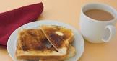](https://www.google.co.uk/url?esrc=s&q=&rct=j&sa=U&url=https://www.herfamily.ie/parenting/tobehonest-tea-toast-giving-birth-best-meal-ever-378461&ved=2ahUKEwjZvqGuqvP5AhUFWcAKHXNHBW0QqoUBegQIBBAB&usg=AOvVaw1bShYZ3Icatp0CqTiD3eXW)

[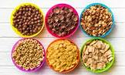](https://www.google.co.uk/url?esrc=s&q=&rct=j&sa=U&url=https://www.newfoodmagazine.com/news/164356/breakfast-cereal-market-soaring/&ved=2ahUKEwjdvsKSqvP5AhUYSkEAHSwOCt0QqoUBegQIDBAB&usg=AOvVaw16yYQPp9skBKthMdfIEQsw)

[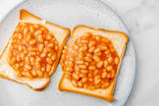](https://www.google.co.uk/url?esrc=s&q=&rct=j&sa=U&url=https://yourcookingbuddy.com/british-baked-beans-on-toast/&ved=2ahUKEwiyy4z1qfP5AhXtRkEAHQ7KD3cQqoUBegQIABAB&usg=AOvVaw0-9SVvjgHWJ-nuMTC2FoQj)

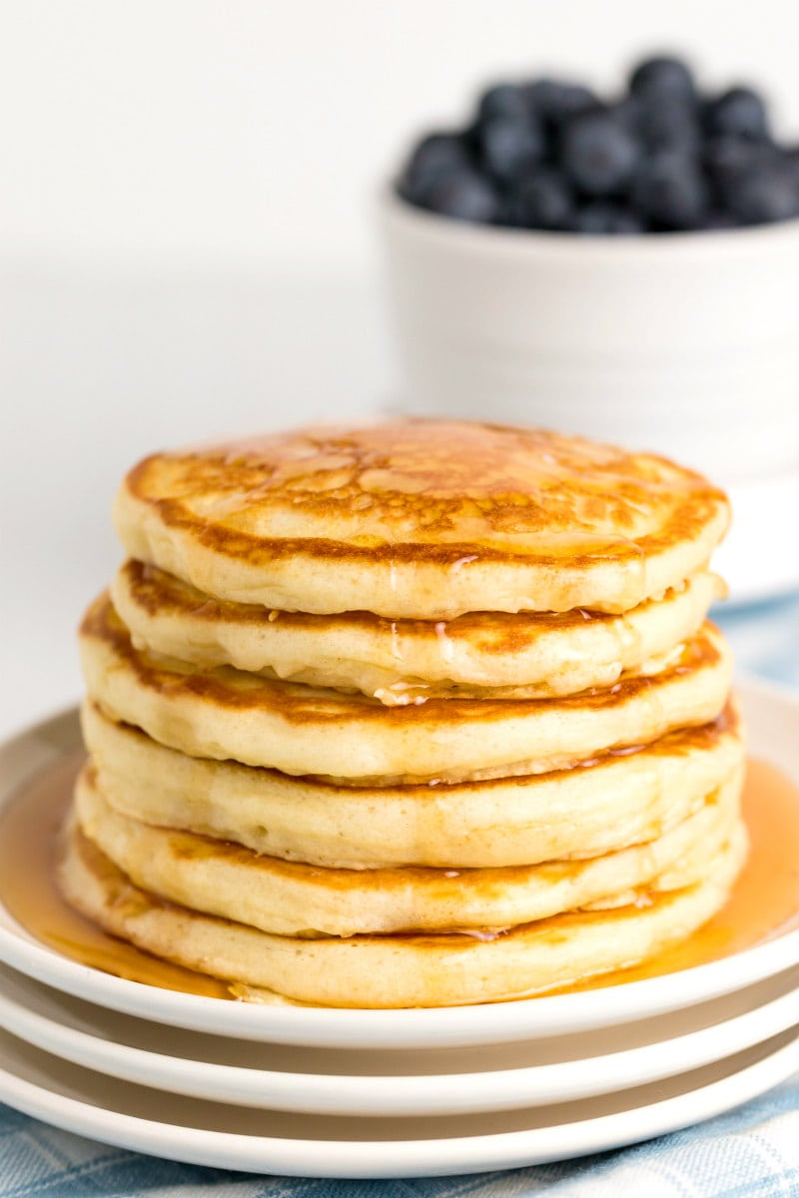

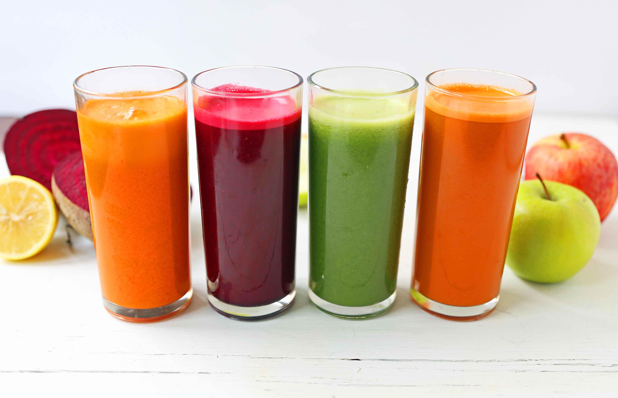

**Daily Special**

Tea/Coffee/Hot Chocolate

+

Cereal/Porridge

+

Slice Buttered Toast/Pancake

**85p**

**Drinks:**

Tea/Coffee/Hot Chocolate 50p

Juice 4oz 35p

**Food:**

Fresh Fruit 40p

Yogurt 55p

Cereal with Milk 30p

Porridge 40p

Toasted-Buttered 25p

Toasted Pancakes 40p

Beans on Toast 55p

Scrambled on Toast (Fri) 55p

Oven Baked Sausages (Fri) 60p