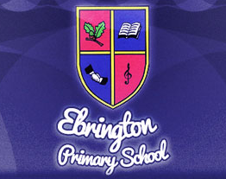
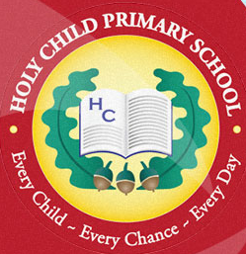
We pledge to grow the seed of peace in our hearts and so produce a rich harvest for the world.

Shared Education Newsletter: April 2017

SHARED EDUCATION INSPECTION: It has been another busy few weeks in the Shared Education schedule…not least having a visit from an ETI inspector, who came specifically to find out all that we have been up to in the Ebrington/Holy Child Partnership. We are delighted to report how impressed she was with her findings- not only with the evidence supplied by the Principals and Shared Education Co-ordinators - but most especially by the group of children she met. This group of 6 children (3 from Ebrington and 3 from Holy Child) brought tears to her eyes as they talked about their desire to see our City united, free from conflict and hostility. They spoke of how much they had enjoyed their Shared Education experience and only wished they could have had more interaction with each other outside the classroom!
PRIMARY SIX: The Primary Six Programme culminated in a celebration trip which saw children from both schools visiting two museums (The Free Derry Museum and Museum of the Apprentice Boys), interspersed with a walking tour of the City Walls. The children thoroughly enjoyed their day and it really was very special to see them exploring the history of our city, hand in hand. Their treat of a MacDonalds’ Happy Meal for lunch was certainly well deserved.
PRIMARY SEVEN: P7 children are now halfway through their Shared Education Programme, and so far have enjoyed exploring their similarities and differences. Last week for example, there was a special focus on investigating the background to their own surnames. It is great to see how the relationships between the children have developed over the last three years. For both groups of children, playtime outside together at the end of the lesson is the highlight of each week. Playing and chatting together is, after all, the most natural way of enhancing these friendships which we hope will last a lifetime!
OTHER EVENTS:
Ebrington P. School, Clooney Campus, 67B Limavady Road, BT47 6LR.
- The classes of Ebrington Primary School look forward to inviting the pupils of Holy Child to come and look around their brand new school! Large, colourful classrooms, Clever Touch screens and a new iMac suite…it really is a school to be proud of. And with a new motto to match that of Holy Child (Every Child, Every Chace, Every Day), Ebrington are certainly not afraid to show that their partnership with Holy Child begins at the deepest level.
- P5 pupils are looking forward to their Shared Education Programme beginning in Term 3. This is such an important stage in the Shared Education journey where children from both schools meet for the first time. The P5 teachers have therefore been hard at work, thinking of fun, motivational activities which will encourage the children to bond from the start. One of these has already begun, with the children from both schools exchanging Pen Pal letters. When they meet for their first lesson, the game of ‘Find Your Pen Pal’ is one not to missed!

Yours sincerely,
Ms Orla Mc Donnell (Holy Child Primary School)
Mr Nigel Dougherty (Ebrington Primary School)

